# Instructions

The web development team has completed the initial development of their new web application and would like to get it up and running on their server. They have requested to be able to access the **/development/website** directory through their Windows desktops via a shared drive.

The would also like the Apache web service to look for files within this directory, starting with the “Under Construction” page created previously.

They will also need to be able to access the system via SSH in order to manage services. Be sure to only allow necessary services through the firewall and configure network settings.

Once complete, please test the file share and web site connections.

HINTS: You can reuse the network settings set by DHCP. You may need to install the Network Manager Tool. Disable SeLinux security for the services to work properly.

# Screenshots

Paste the required screen shots under each description.

1. Paste a screen shot showing the manually set network settings in the Network Manager TUI

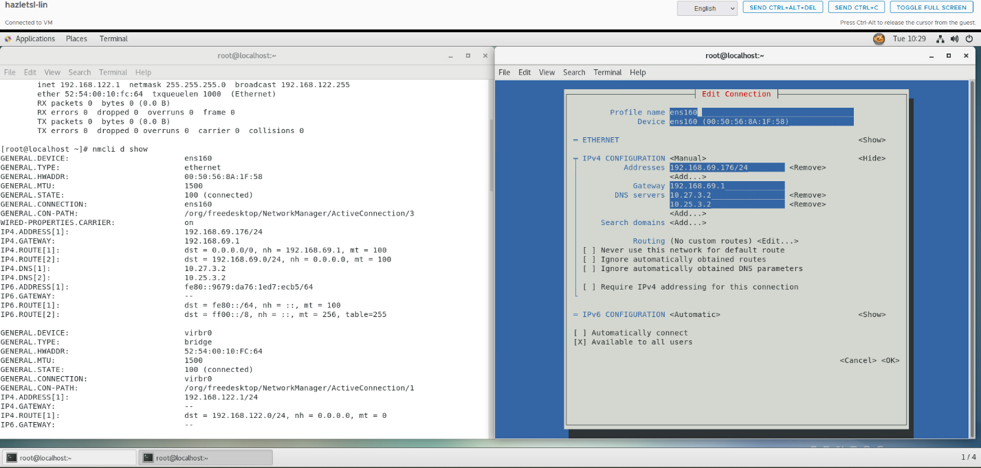

1. Paste a screen shot showing the allowed services through the Firewall

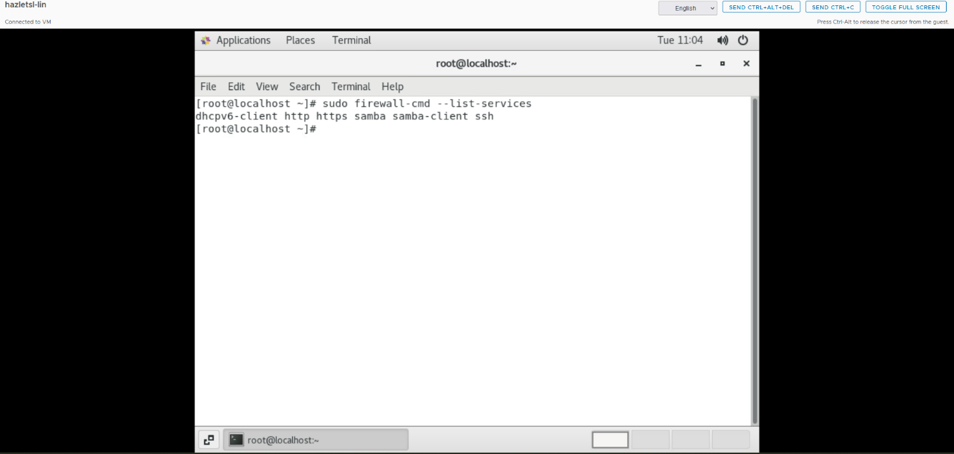

1. Paste a screen shot showing the Samba configuration settings

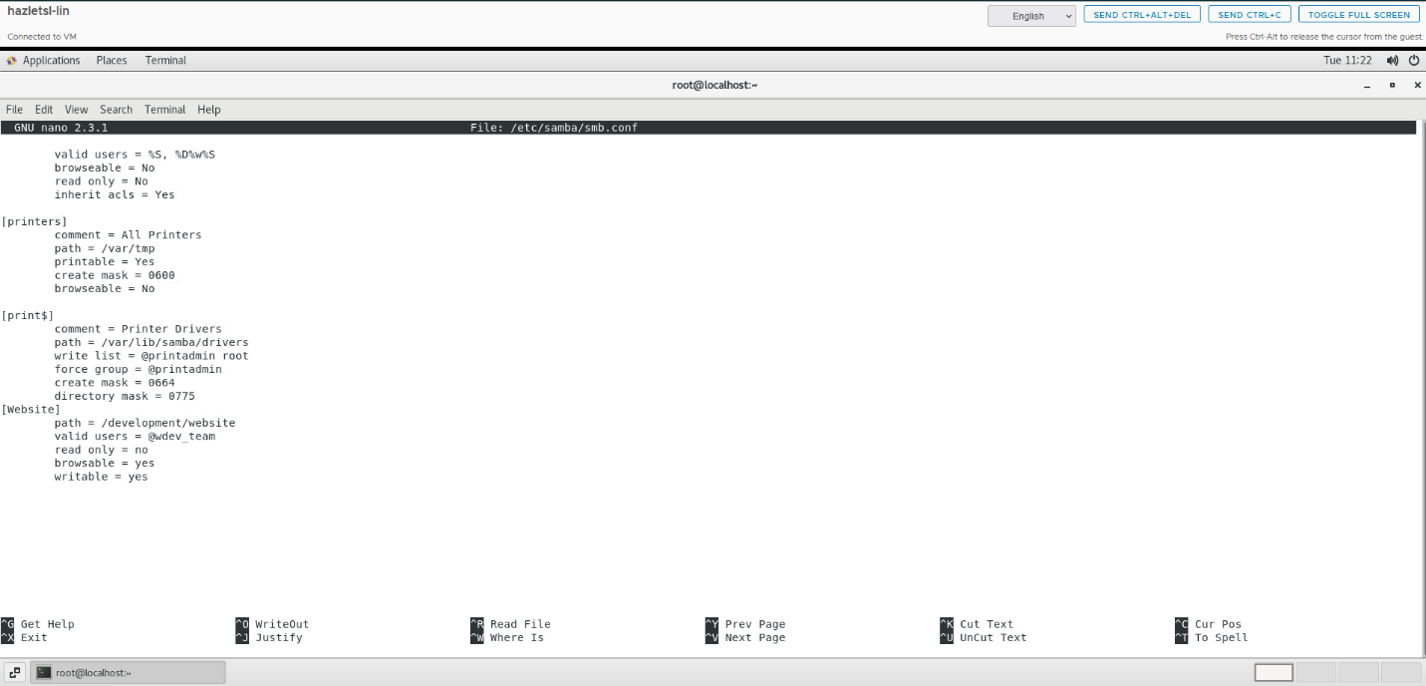

1. Paste a screen shot showing a web dev user accessing the shared folder through File Explorer
2. Paste a screen shot showing the “Under Construction” web page in a web browser. (Must use http://)

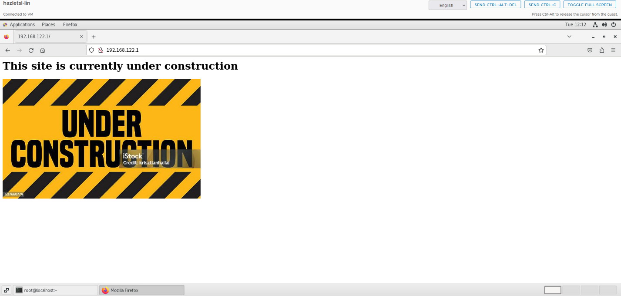

# Documentation

Record and explain all the steps you took to complete the task. Include any commands used, screen shots showing GUI interfaces, or any other information that would help you recreate the task.

**Note: You will be allowed to use this documentation to help you complete future assignments.**

**Open Network Manager TUI**:

* sudo nmtui

**Edit Network Connection**:

* Choose **Edit a connection**.
* Select your network interface eth0 and Manual
* Set IP settings
* Save and exit.

**Restart Network Service**:

sudo systemctl restart network

**Verify Network Configuration**:

ip addr show

**Enable Apache, Samba, and SSH Through the Firewall**:

Ran these commands:

sudo firewall-cmd --permanent --add-service=http

sudo firewall-cmd --permanent --add-service=samba

sudo firewall-cmd --permanent --add-service=ssh

sudo firewall-cmd --permanent --add-service=samba-client

reloaded firewall:

sudo firewall-cmd –reload

**Verify the Allowed Services**:

sudo firewall-cmd --list-all

Configure Samba for Shared Directory Access:

Edit the Samba configuration file:

sudo nano /etc/samba/smb.conf

Add the following at the bottom of the file to share /development/website

[website]

path = /development/website

valid users = wdev_team

read only = no

browsable = yes

add wdev_team to samba:

sudo useradd webdev

sudo smbpasswd -a webdev

**Set Permissions on the Shared Directory**:

sudo chown -R webdev:webdev /development/website

sudo chmod -R 775 /development/website

**Start and Enable Samba Services**:

sudo systemctl start smb

sudo systemctl start nmb

sudo systemctl enable smb

sudo systemctl enable nmb

**Verify Samba Configuration**:

Testparm

Unable to complete step 4. Tried connecting in putty but always said network connection timed out. Tried troubleshooting it but was unable to fix.

Set Up Apache to Serve Files from /development/website

Edit the Apache configuration file:

sudo nano /etc/httpd/conf/httpd.conf

Change the DocumentRoot to point to /development/website:

DocumentRoot "/development/website"

<Directory "/development/website">

AllowOverride None

Require all granted

</Directory>

**Restart Apache**:

sudo systemctl restart httpd

**Verify Apache is Running**:

sudo systemctl status httpd

Open Web Browser:

http://192.168.122.1